String Formatting & Manipulation

1. Write a function that capitalizes the first letter of each word in a string.

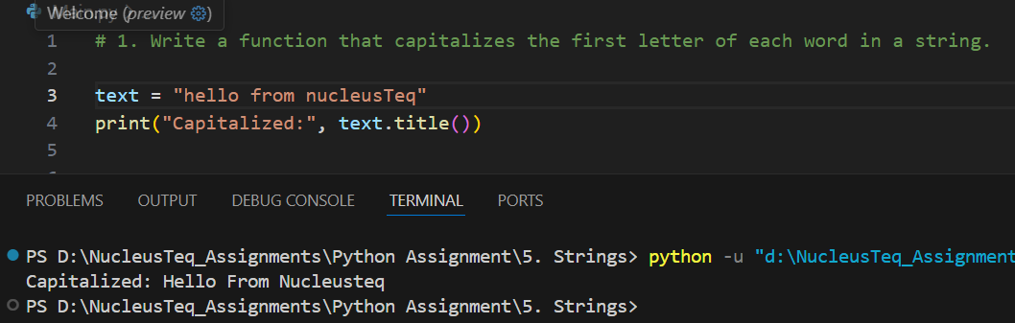

2. Create a program that finds all substrings of a given string.

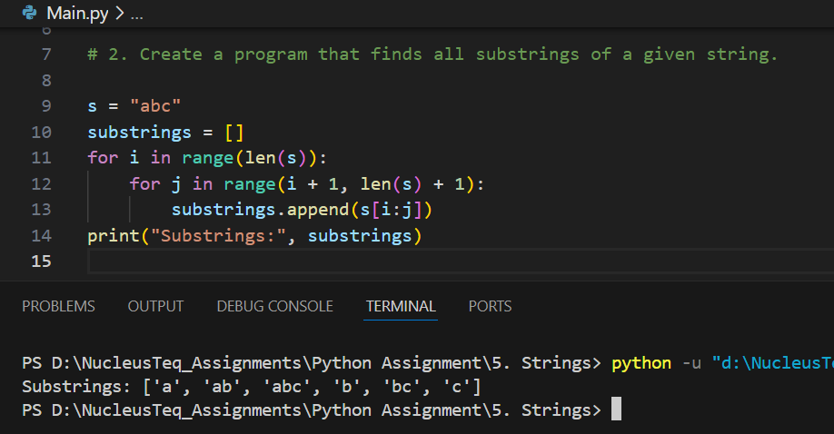

3. Write a function that replaces all vowels in a string with '\*' symbol.

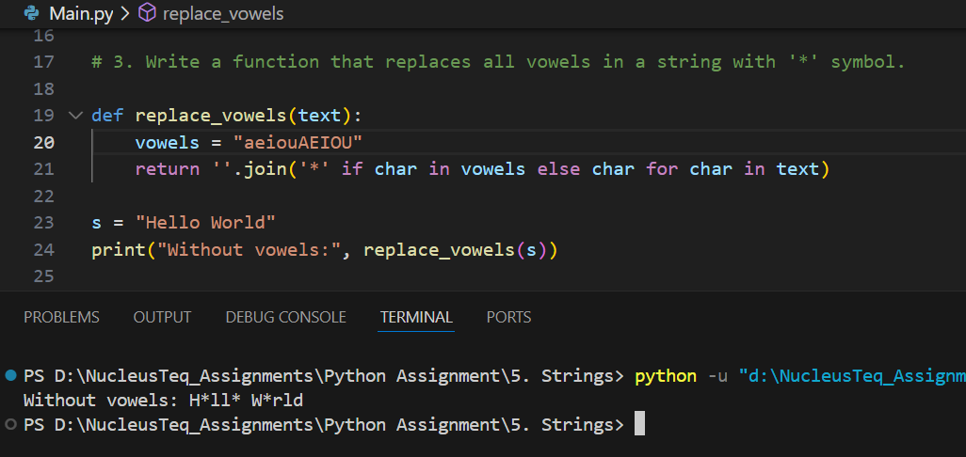

4. Develop a function that counts words, characters, and lines in a string.

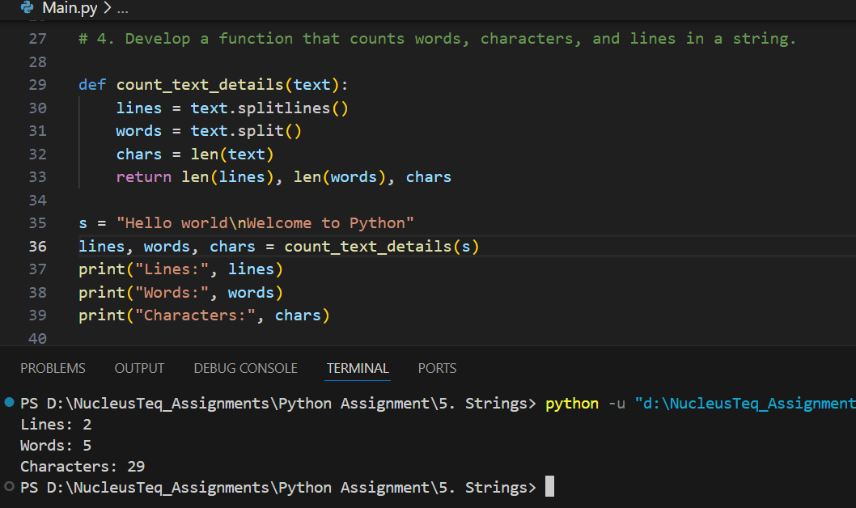

5. Write a script to format a number as currency (e.g., 1000000 -> 1,000,000).

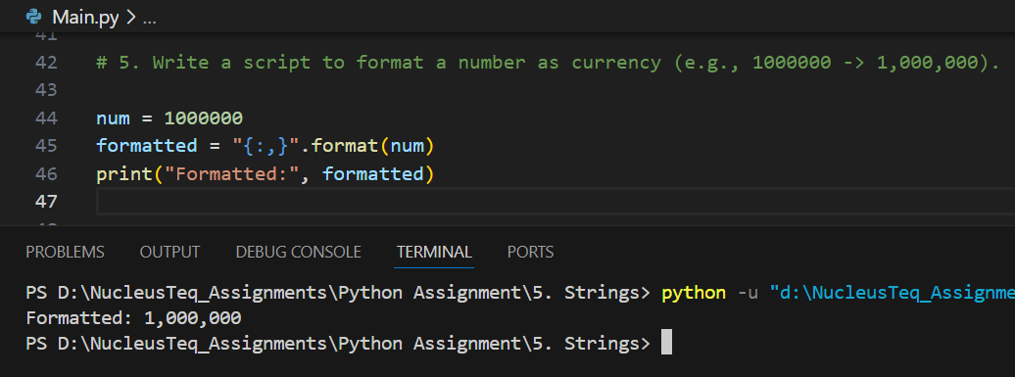

6. Implement a function that validates a strong password based on given criteria.

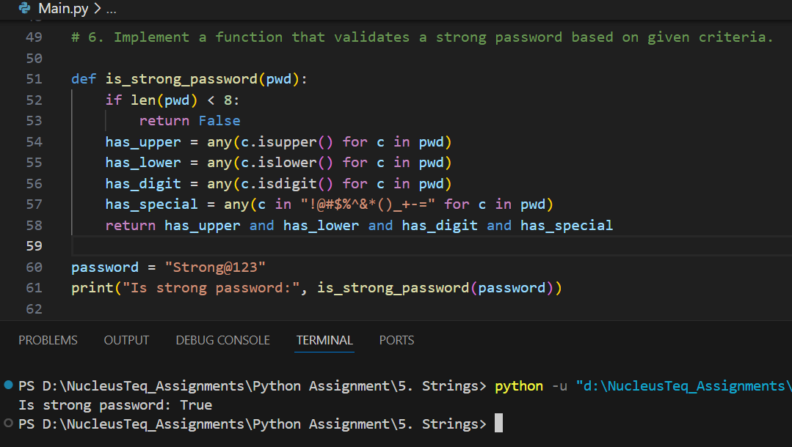

7. Write a script that encodes a string using Caesar cipher.

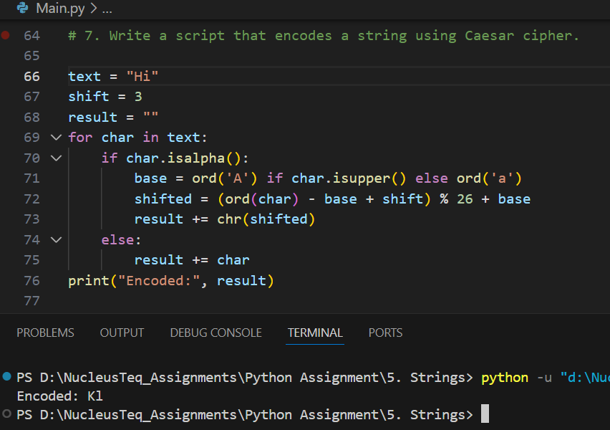

8. Create a function to remove HTML tags from a string.

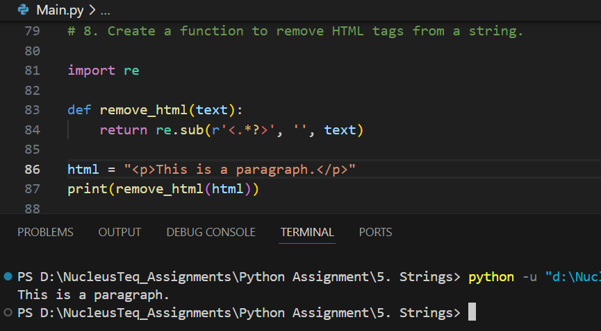

9. Develop a function that finds the longest palindromic substring.

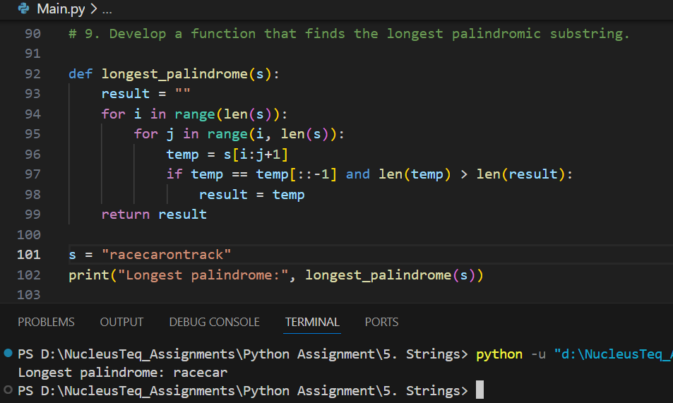

10. Implement a string compression algorithm (e.g., aabcccccaaa -> a2b1c5a3).

